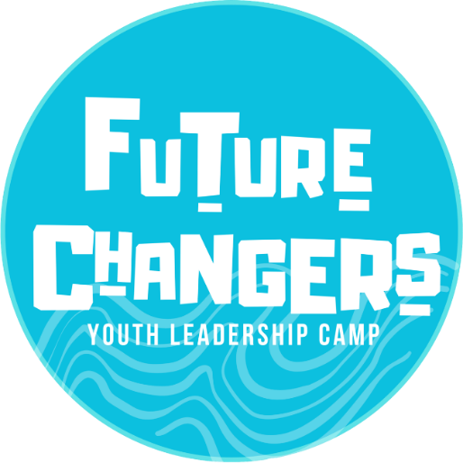
FUTURE CHANGER’S
Youth Leadership Camp
When: 13th-15th January 2025
Ages: 12-17 years old
Venue: Spring Beach Youth Campsite
Cost: Free to 15 successful applicants from the West Tamar

It is a 3-day Youth Leadership camp. Successful applicants from the West Tamar will join George Town’s Seagulls to Chips participants. A bus is supplied from the West Tamar to the campsite and return. There are team challenges, fun, adventurous activities such as rock climbing, flying fox, abseiling and crate stacking! There is also mindfulness and wellness programs. The camp encourages self-growth and development and promotes community engagement in young people.

APPLICATIONS NOW OPEN
(Closing Friday 15th November 2024)

For further information please contact:
_____________________________________________________________________________________________________________________________
Kirsten Howard  Youth Development Officer |  | 
Mobile:  Telephone:  Email:  Web: | 0437 789 103  03 6323 9200  kirsten.howard@wtc.tas.gov.au  www.westtamaryouth.com.au

Applicant’s Name
Postal Address
Phone Number
Email Address
Date of Birth
School
Parent’s name and phone number
Why are you applying for this camp?
Give an example of a time where you have handled a challenging situation?
What do you want to achieve by attending this camp?
What do you believe your greatest skill is?

What contributions have you made to your community?
You MUST attach something that shows how you can be, or already are an inspiring leader. Get Creative! | (Examples include a photo, video, poster, persuasive text, written reference, 3 step plan, mind map, stories, and ideas to improve the West Tamar etc.)

Please return this completed form and attachment to
Kirsten Howard (Youth Development Officer)
1 Windsor Drive, Riverside, TAS, 7250
OR West Tamar Council (PO Box 16 Riverside, TAS, 7250)
Email: kirsten.howard@wtc.tas.gov.au

