 | Newstead College  Cypress St, Newstead 7250  Ph (03) 63323232
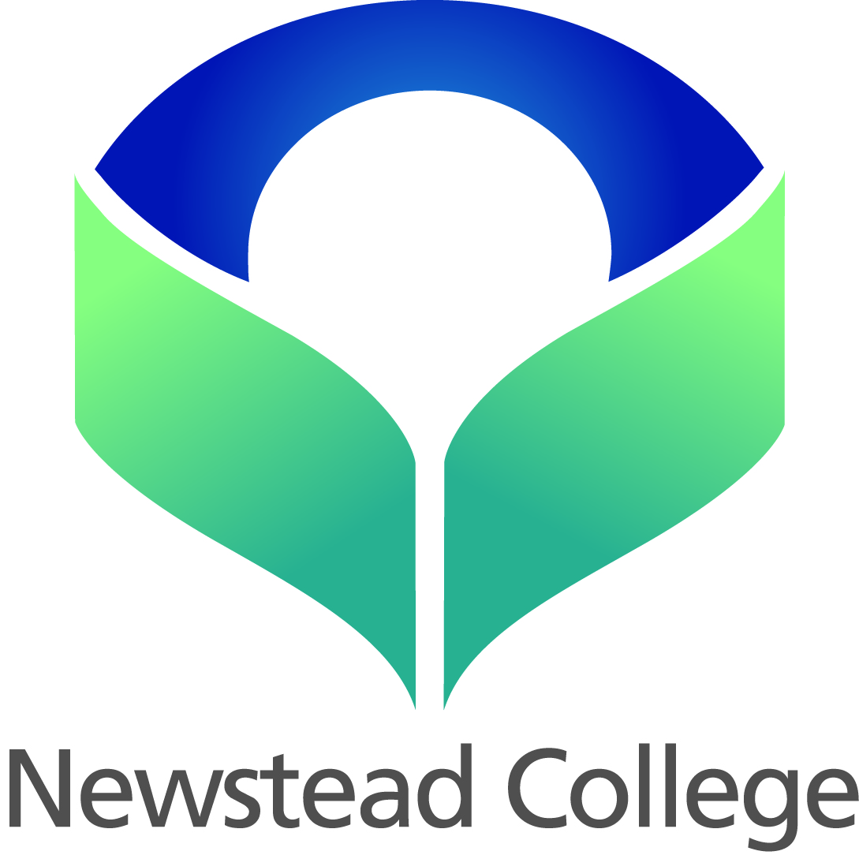

Dear Claire Beams,

Congratulations on your selection for the 2025 Newstead College Gold Coast Netball team competing at the International Netball Festival in July.

Details about cost and itinerary will be distributed during the first team meeting. This will be held on Tuesday the 25nd of March during Enrichment in room 37.

Well done!

Kind regards

Felicity Smith and Carolyn Robinson
Newstead College | Department of Education

P: (03) 6332 3206
E: felicity.smith@decyp.tas.gov.au or carolyn.robinson@decyp.tas.gov.au

