Congratulations. You Have Been Selected for Team Tasmania

17th January, 2022 Athlete SOMS Number: 110318

Sarah Squires
5 Kelso Jetty Road
Kelso Tasmania 7270

Dear Sarah,

I am delighted to inform you that you have been invited to represent Team TAS in Swimming at the 2022 Special Olympics Australia National Games. The Games are the pinnacle of competition in Special Olympics Australia and only come around every four years. This time they’ll be held in Launceston, Tasmania from 16-21 October 2022.

To cover the costs of participating, each Athlete Levy is a total of $2,700. This includes your deposit of $500 which is non-refundable.
It includes: Accommodation, meals, transport, uniforms, team support, venue hire, technical delegates, training camp, medals and ribbons, safety and medical, as well as COVID mitigation and contingency plans.
Levy payments are to be paid in four instalments as shown below:
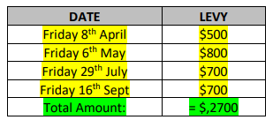

*The final amount may be reduced subject to sponsorship and fundraising.
Please deposit these funds directly to Special Olympics Tasmania to be passed onto Special Olympics Australia.
Congratulations again on being chosen to represent Tasmania. If you have any questions, please contact Head of Delegation, Vanessa Abernethy via email teamtas@specialolympics.com.au

Yours sincerely,
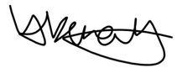

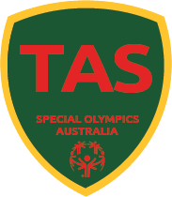
Vanessa Abernethy
Head of Delegation
Special Olympics Tasmania
Email teamtas@specialolympics.com.au

