
Partner with us as a valued sponsor!
We are so excited to share that Launceston Christian School has won our tenth State Championship at the Science and Engineering Challenge in Hobart. We now have the privilege of representing our beloved Apple Isle in the finals, which will be held in Sydney in October 2023.
We would love you to consider partnering with us as we fund flights, accommodation, and other expenses related to this incredible experience. We have 31 Year 9 and 10 students on the team, and they are a wonderful, enthusiastic group that share a passion for STEM subjects. With their teachers, they have put in many hours preparing for this event and would love you to partner with them in this opportunity.
Last year we came second at the national competitions – an incredible achievement for our small state, and we received a lot of media attention around our participation and runner-up place. We have previously won two national competitions, in 2011 and 2018, which garnered national recognition on many media platforms.
WHAT WE NEED:
Our costs amount to approximately $23,000 this year. We would love you to consider sponsoring us and have the following packages available for you to consider:
PLATINUM $5000+
Extra-large company logo on the front of the team uniform and on all physical posters that will be placed around the school, and virtual communication within our community about the competition.
Photo opportunities with the team that will be included in any external media and internal communications around the event.
Photo opportunities with the team and your business tagged in every Science & Engineering Competition related post on social media.
GOLD $3000-4999
Large company logo on the front of the team uniform and on all physical posters that will be placed in the school, and virtual communication within our community about the competition. Your business is tagged on our social media posts and newsletter.
SILVER $1000-2999
Company logo on the sleeve of the team shirt, and medium-sized logo on any internal and external posters and communications. Tagging in social media posts relating to the event.
BRONZE all donations up to $999
Company logo included on all internal communications: our newsletter and posters displayed virtually and physically around the campus.

SOME STATS for how this could benefit your business:
Last month, our Facebook page reached over 7,500 individual accounts, and our win at the State Final in Hobart resulted in television news reports and newspaper articles. Our participation in the National Finals has previously garnered similar media attention, and we are excited to publicise and partner with your business. Our newsletter, The Herald, has almost 800 subscribers.
Please consider partnering with us. If you are keen to help our team, please get in touch with our Marketing and Communications Manager, Rebekah Peters, at petersr@lcs.tas.edu.au or call the office on 03 6327 2854.
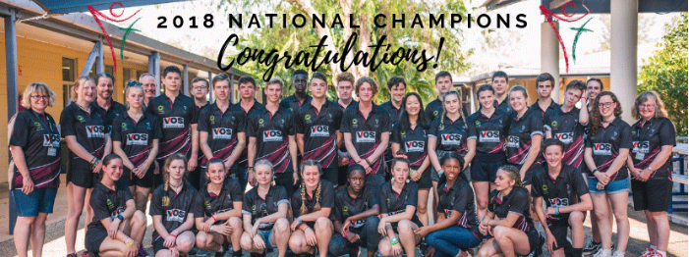

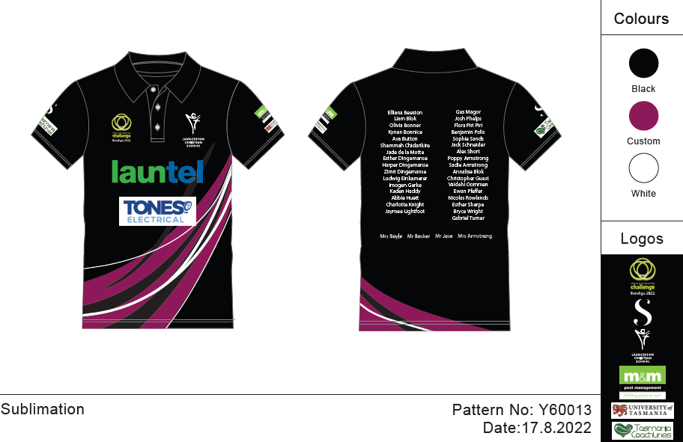

Example of last year’s polo:

