Cindy & Shannon Dunn
120 Paper Beach Rd
Swan Point TAS 7275
Cindy.dunn.74@gmail.com
0417386841

West Tamar Council
C/-

To Whom it may concern,
My name is Shannon Dunn and I play junior football with Tamar Valley Junior football (AKA Tamar Demons) club within the Northern Tasmania Junior Football Association.
I am excited to let you know that I have been selected to play in the under 15 Tasmania team to compete in the ‘School Sport Australia’ competition in Ballarat at the end of July.
Our first initial fee is $1200 to Schools Sports Australia (Tasmania) and we need to also pay our own flights and accommodation. My mum, Cindy Dunn will be accompanying me.
I am writing to you as I am seeking financial support to get me to Ballarat to play other states during 22nd July to 28th July.
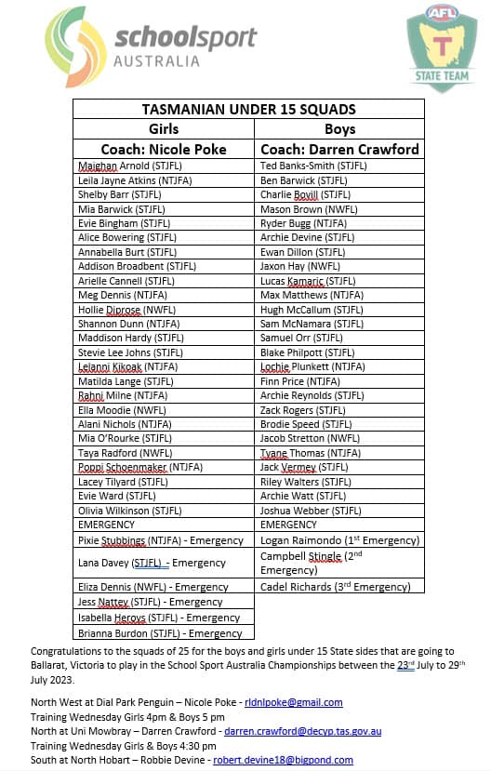
We would appreciate any donation that you are able to make.
Sincerely
Shannon - Cindy & Jerome Dunn

