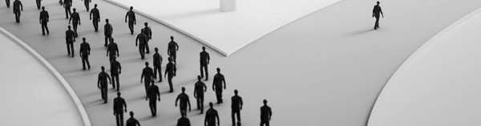
YOUR Choices Are Shaping YOUR Future
Unaware Tasmanian teenagers are being manipulated into the choices they make every day by their peers, not realising the consequences.
By Nicole Williams
15th of June 7:59_{pm}
Everyone has experienced peer pressure at least once or twice in their lifetime, which is why most people do not seem to think of it as a serious problem. Teens all over Tasmania are suffering with dealing with peer pressure. Allyse, a grade eight school student, claimed “I’m scared I will lose my friends, or they will start rumours, so I give in.” This can be a significant problem.
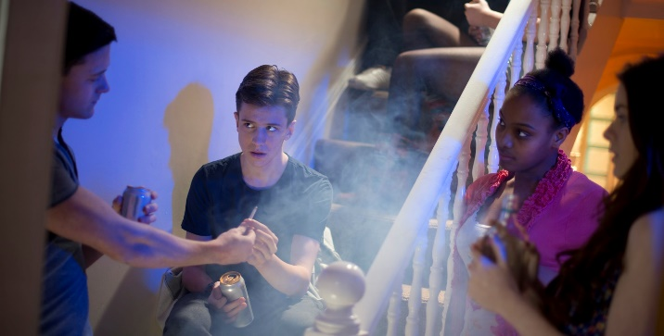
Your reputation is built off your everyday actions and words. It is extremely difficult to change your reputation in someone else’s mind. By teens giving in to peer pressure, it could be something as simple as getting you to sing in front of your friends or it could be more serious like shoplifting, smoking, taking drugs and drinking alcohol. In the moment it can feel great but then when it is over, you begin to feel the guilt.
When we are put in an awkward situation with a group of people, instinct tells us to look over at someone else to see what’s accepted and what’s not, which influences us to act in the way that we will feel accepted, even if it’s by doing something wrong. What teens aren’t realising is that they themselves are also influencing others. People might hear the things you say and be terrified of what you might think of them which can lead to huge problems such as changing their physical appearance, social anxiety, eating disorders and depression.
It is proven that we all get influenced by the top 5 people we spend the most time with. We start to act like them and even speak like them. Don’t believe me? Think about it yourself. Teens don’t realise that they are in at least one other person’s top 5. They are influencing others to act a certain way without even realising it. If you do something that feels wrong, others will not only be influenced by it but will paint a picture in their head of the type of person you are.
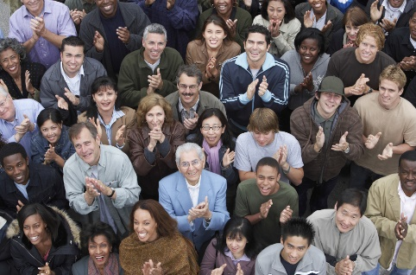
Teens need to be informed of this issue and the problem it has become. Not only teens but we all need to stop and think… Who influences me to the best version of myself? Who are the people that genuinely make me happy for who I am? If you start to spend more and more time with those people, they will soon be your top 5 and your actions and words will be influenced in a good way. You will find yourself happier. You will still be influencing others but this time by setting a good example. And others will look up to you for that.
Peer pressure (for teens) - nemours kidshealth. (n.d.). Retrieved from https://kidshealth.org/en/teens/peer-pressure.html | What are the major mental health issues for teenagers? | hcf (n.d.). Retrieved from https://www.hcf.com.au/health-agenda/body-mind/mental-health/what-are-the-major-mental-health-issues-for-teenagers |Kay, M. (n.d.). How to use cognitive biases for effective marketing psychology for marketers. Image Retrieved from https://psychologyformarketers.com/use-cognitive-biases-effective-marketing/ | Hardy, M., MSEd., & Bcc. (n.d.). Type of peer pressure lovetoknow. LoveToKnow. Image Retrieved from https://teens.lovetoknow.com/Type_of_Peer_Pressure | Information received from guest speaker Will smith at Yac leadership camp 2020 camp clayton https://jcpyouth.com.au/event-speakers/ | How our choices shape our lives - titanium success. (n.d.). Titanium Success. Image Retrieved from https://titaniumsuccess.com/podcast/how-our-choices-shape-our-lives/

